In 10th and 11th grade, I took *Calculus*.

Integration

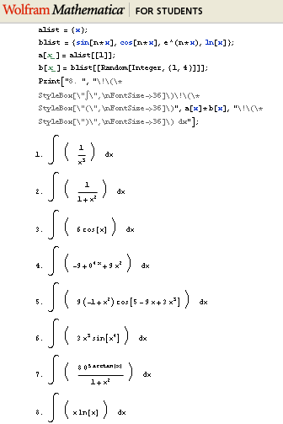

Integration is a function to measure the area under a curve. Lots of practice required.

I learned the integral of sin(x)cos(x) is –cos2(x)/2, and more.

Vectors



This shows the cross product between a vector and a vector normal to it. The resultant vector is perpendicular to the two.

I learned that:

